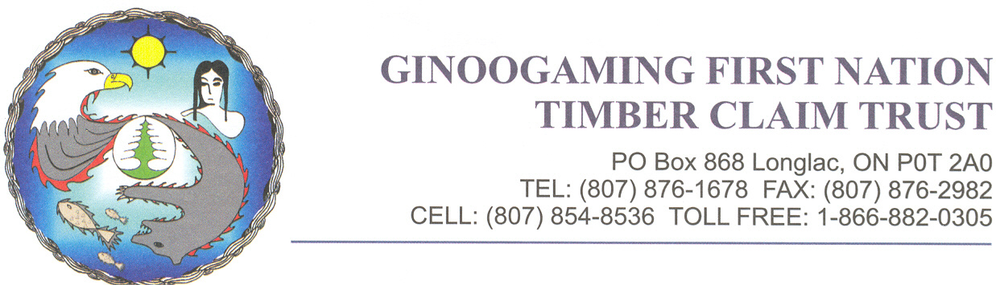

October 21, 2024

Dear Ginoogaming First Nation Member,

**The Board of Trustees & Chief and Council invite you to attend the**

**Ginoogaming First Nation Timber Claim Trust**

**ANNUAL COMMUNITY MEETING**

**WHEN:** Friday November 1, 2024 1:00 PM

**WHERE: Ginoogaming Training Centre**

*Community Feast will be served at 4pm as well as a Free penny auction*

We look forward to your participation.

If you require more information, please contact the Timber Claim office at:

1-866-882-0305 -or- 807- 876-1678

Meegwetch

***Stay informed…visit the Ginoogaming website for up-to-date information***

**http://www.ginoogaming.ca/**