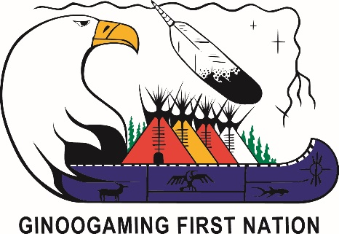
TO ALL GINOOGAMING FIRST NATION MEMBERS
Temporary Employment Opportunity
Economic Development Officer
POSITION SUMMARY:

The Ginoogaming First Nation (GFN) Economic Development Officer (EDO) is responsible for planning, developing, coordinating and implementing economic development policies, strategies, and initiatives that improve the community’s socio-economic status with a business development strategy that identifies the needs of the First Nation.
Working time is divided between the office, meeting with community members, and travelling to through the province as necessary. EDO’s are to use a grass root perspective to locate and meet with individuals, businesses, key contacts, attend regular meetings with Chief & Council to provide updates.
The EDO must be prepared to work with excellent organizational and preparation skills to ensure they have the necessary tools to complete tasks while working away from the office. The EDO must be prepared to travel, according to the needs of community, businesses, key contacts, tribal councils, PTOs and government service providers.

DUTIES & RESPONSIBILITIES

The Economic Development Officer is responsible for continuously developing and maintaining knowledge required to-do the job by understanding, embracing, and contributing to the community’s economic development strategic plan, as an approach towards effective planning, by collaborating effectively to coordinate economic development for Ginoogaming First Nation.
The EDO must be familiar with background materials and information relating to Ginoogaming First Nation. Must demonstrate a non-political approach to communicate and foster relationships with politicians, Elders, Youth and community members. The EDO must use a variety of qualitative and quantitative methods to perform continuous assessment of economic development needs, including maintaining an inventory of existing businesses, sector activities and current human resources in the community.
The EDO must ensure that the Ginoogaming First Nation economic development initiatives and opportunities are communicated to key stakeholders. The EDO must demonstrate good written and oral
communication skills that are relevant to the position as this will require the EDO to prepare proposals for a variety of economic development opportunities for submission to public and private funding sources. Must write project briefs, updates and final reports for all project activities taking place in Ginoogaming First Nation.

The EDO must maintain a sound administrative and organizational system, develop budgets and cash flow projections, use business planning software, and create presentations for public speaking opportunities. The EDO must also develop and track accomplishments related to an ongoing work plan that will guide the work in Ginoogaming First Nation.

Must demonstrate the following personal attributes:
- Reliable
- Enthusiastic
- Punctual
Term: Temporary Full-time, with possibility of extension
Location: Ginoogaming First Nation, Band Office
Salary: Negotiated based on experience
Application Deadline: November 30, 2018 at 4:30pm EST

Please submit resume and cover letter to the attention of Conrad Chapais by one of the following:

1. Electronic copy to: conrad.chapais@ginoogamingfn.ca

2. Mail Hardcopy to: Conrad Chapais
Band Manager
P.O. Box 89, Longlac
ON, P0T 2A0

3. Fax Transmission: (807) 876-2495

If you have any questions please contact our office at (807) 876-2242. We thank all applicants for their interest, however only those selected for an interview will be contacted.

